 | A G E N D A  Main Street board  SPECIAL CALLED Teleconference Meeting  Main Street Department  Teleconference  Monday, May 11, 2020  Noon | 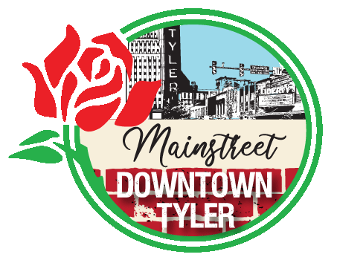

Due to the current Coronavirus COVID-19 public health emergency, a teleconference meeting of the Tyler Main Street Board is being conducted instead of a meeting providing for physical access to the public. Members of the public may participate by listening to the meeting and calling with comments to (903) 405-2571, conference ID: 608 343 862#

Members of the public may participate by watching the meeting live at shorturl.at/etx03.

*********************************************************************************
Please call (903) 593-6905 if you need assistance with interpretation or translation for this City meeting.
Si usted necesita ayuda con la interpretación o traducción de cualquier material en este sitio o en una reunión pública de la Ciudad de Tyler por favor llame al (903) 595-7248.

*********************************************************************************

AMERICANS WITH DISABILITIES ACT NOTICE
The City of Tyler wants to ensure that City meetings are accessible to persons with disabilities. If any individual needs special assistance or accommodations in order to attend this board meeting please contact the Main Street Department at (903) 593-6905 in advance so accommodations can be made.
*********************************************************************************

Call to Order and establish quorum.

- Review and vote on requests for reimbursement from the 2019 Downtown Revitalization Grant recipients.
- Shane Murphy (430 Elm)
- Rick Eltife (100, 104 and 108 W Erwin)
- Discovery Science Place (308 N Broadway)

- Adjourn.

