 | G A T H E R I N G N O T I C E  TYLER POLICE DEPARTMENT  NATIONAL NIGHT OUT  City Council Gathering  City of Tyler Municipal Courts  813 N. Broadway  Tyler, Texas  Tuesday, October 4, 2022  6:00 pm until 8:00 pm | 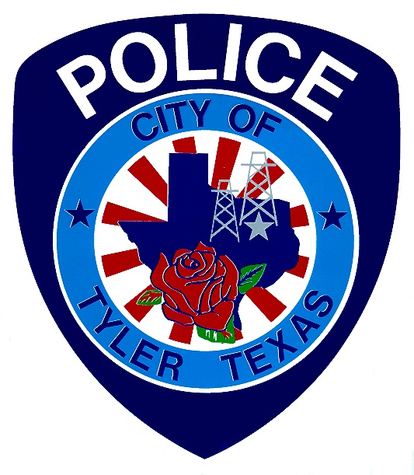

Please call (903) 531-1015 if you need assistance with interpretation or translation for this City gathering.

Si usted necesita ayuda con la interpretación o traducción de cualquier material en este sitio o en una reunión pública de la Ciudad de Tyler por favor llame al (903)531-1015.
*********************************************************************************

AMERICANS WITH DISABILITIES ACT NOTICE
The City of Tyler wants to ensure that City Council gatherings are accessible to persons with disabilities. If any individual needs special assistance or accommodations in order to attend this City Council gathering please contact Tyler Police Department at (903) 531-1015 in advance so accommodations can be made.
*********************************************************************************

E M E R G E N C Y N O T I C E

WHEREAS, notice of City gatherings is regularly and routinely posted at least seventy-two (72) hours prior to the meeting in accordance with Texas Gov’t Code Sec. 551.043; and

WHEREAS, due to unforeseen circumstances, notice of this City Gathering was not posted at least 72 hours prior to the gathering; and

WHEREAS, Texas Gov’t Code Sec. 551.045(a) provides that in an emergency or when there is an urgent public necessity, the notice of a meeting or the supplemental notice of a subject added as an item to the agenda for which notice has been posted in accordance with Tex. Gov’t Code Chapter 551, Subchapter C. is sufficient if it is posted at least one (1) hour before the meeting is convened;

WHEREAS, information was previously sent to persons planning to attend the event; and

WHEREAS, it would create a severe hardship to persons planning to attend this gathering if the scheduled event was cancelled; and

NOW, THEREFORE, pursuant to Texas Gov’t Code Sec. 551.045, emergency notice for the National Night Out on Tuesday, October 4, 2022, from 6:00p.m. – 8:00 p.m., located at 813 N. Broadway in Tyler, Texas 75702, is hereby posted as follows:

The Tyler Police Department is hosting National Night Out. There is the possibility that a quorum of the Tyler City Council will be present at the National Night Out on Tuesday, October 4, 2022, between 6:00 pm and 8:00 pm., located at 813 N. Broadway, Tyler, TX 75702.

Although some City-related items may be discussed, no action items will be considered by the City Council and no official action by the City Council is scheduled to be taken during this event.

CERTIFICATE OF POSTING

This is to certify that on the _______ day of _________________, 2022, at _________ M., the above notice was posted on the bulletin boards of City Hall.

_______________________________________
City Clerk or Staff Designee

This is to certify that on the _______ day of _________________, 2022, at _________ M., the above notice was posted on the front door of Tyler Police Department, 711 W. Ferguson St, Tyler, Texas.
________________________________________
Staff Designee

